727721euai009

Atchaya R

**1.**

**package** com.example.demo.sampletesting;

**import** org.openqa.selenium.By;

**import** org.openqa.selenium.WebDriver;

**import** org.openqa.selenium.edge.EdgeDriver;

**import** org.testng.Assert;

**import** io.github.bonigarcia.wdm.WebDriverManager;

/**

* Hello world!

*

*/

**public** **class** NewTest2

{

**public** **static** **void** main( String[] args ) **throws** InterruptedException

{

WebDriverManager.*edgedriver*().setup();

WebDriver driver = **new** EdgeDriver();

driver.get("https://www.amazon.in/OnePlus-Nord-Black-128GB-Storage/dp/B09WQY65HN/ref=sr_1_1_sspa?crid=2G7HB85JSVFB2&keywords=oneplus+nord+ce+3+lite+5g&qid=1683193946&sprefix=oneplus+nord%2Caps%2C298&sr=8-1-spons&sp_csd=d2lkZ2V0TmFtZT1zcF9hdGY&psc=1");

driver.manage().window().maximize();

//

driver.findElement(By.*xpath*("//*[@id=\"add-to-cart-button\"]")).click();

Thread.*sleep*(5000);

Boolean present = driver.findElement(By.*xpath*("//*[@id=\"attach-close_sideSheet-link\"]")).isDisplayed();

System.***out***.println("Is item added to cart:" + present);

driver.get("https://www.amazon.in/gp/cart/view.html/ref=dp_atch_dss_cart?");

Thread.*sleep*(5000);

driver.findElement(By.*xpath*("//*[@value=\"Delete\"]")).click();

Thread.*sleep*(2000);

String removeText = driver.findElement(By.*xpath*("//*[@id=\"sc-active-cart\"]/div/div[1]/div/h1")).getText();

String extext = "Your Amazon Cart is empty.";

**if**(removeText.equals(extext)) {

System.***out***.println("Product is removed");

}

driver.get("https://www.amazon.in/OnePlus-Nord-Black-128GB-Storage/dp/B09WQY65HN/ref=sr_1_1_sspa?crid=2G7HB85JSVFB2&keywords=oneplus+nord+ce+3+lite+5g&qid=1683193946&sprefix=oneplus+nord%2Caps%2C298&sr=8-1-spons&sp_csd=d2lkZ2V0TmFtZT1zcF9hdGY&psc=1");

driver.findElement(By.*xpath*("//*[@id=\"add-to-cart-button\"]")).click();

Thread.*sleep*(2000);

driver.get("https://www.amazon.in/gp/cart/view.html/ref=dp_atch_dss_cart?");

Thread.*sleep*(5000);

driver.findElement(By.*xpath*("//*[@id=\"a-autoid-0-announce\"]")).click();

driver.findElement(By.*xpath*("//*[@id=\"quantity_2\"]")).click();

Thread.*sleep*(2000);

driver.findElement(By.*xpath*("//*[@name=\"proceedToRetailCheckout\"] "));

Thread.*sleep*(1000);

String sign = driver.getTitle();

System.***out***.println(sign);

String esign = "Amazon Sign In";

**if**(sign.equals(esign)) {

System.***out***.println("Success");

}

**else** {

System.***out***.println("Failure");

}

}

}

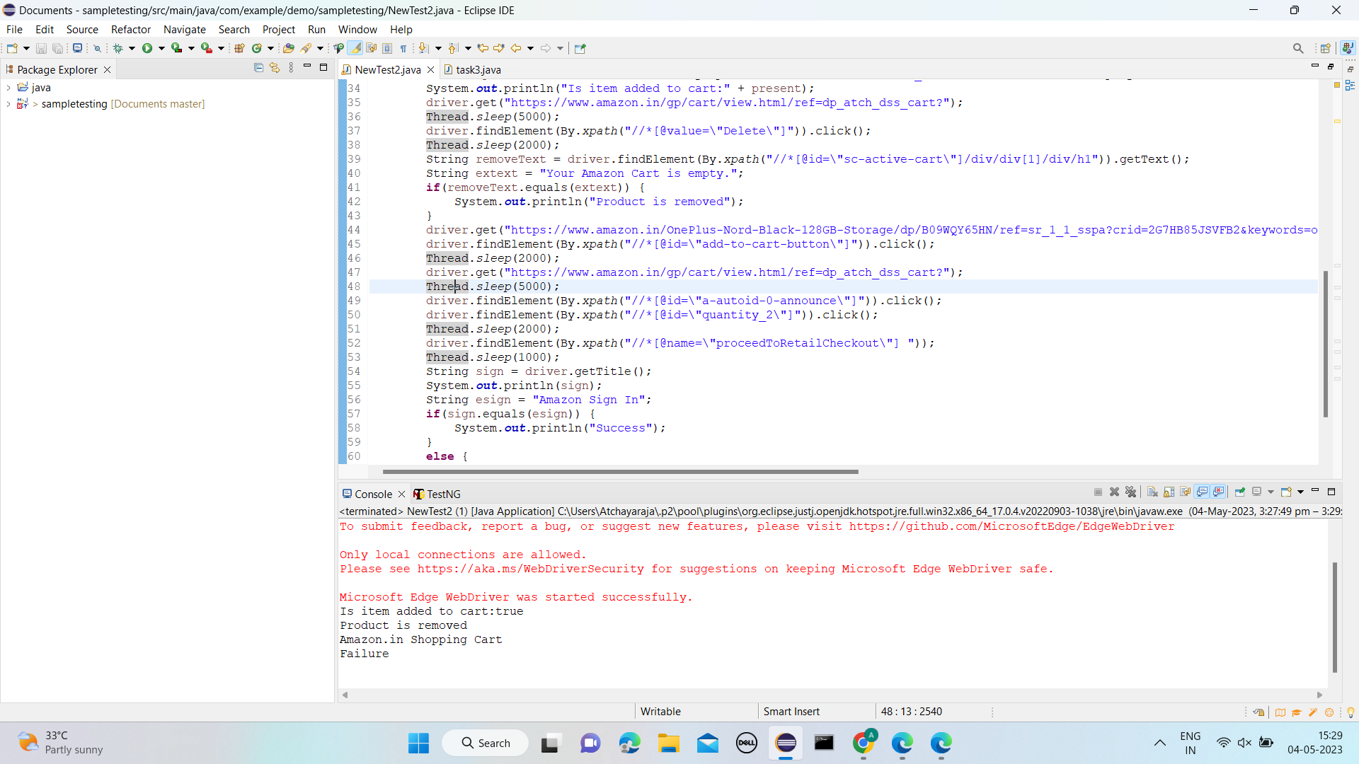

2.

**package** com.example.thursday.selproj2;

**import** org.openqa.selenium.By;

**import** org.openqa.selenium.WebDriver;

**import** org.openqa.selenium.WebElement;

**import** org.openqa.selenium.chrome.ChromeDriver;

**import** org.openqa.selenium.chrome.ChromeOptions;

**import** org.openqa.selenium.edge.EdgeDriver;

**import** io.github.bonigarcia.wdm.WebDriverManager;

**public** **class** task3 {

**public** **static** **void** main(String[] args) {

WebDriverManager.*edgedriver*().setup();

WebDriver driver = **new** EdgeDriver();

driver.get ("https://www.amazon.in/");

driver.manage().window().maximize() ;

String currentTitle=driver.getTitle();

System.***out***.println(currentTitle);

String expectedTitle="Online Shopping site in India: Shop Online for Mobiles, Books, Watches, Shoes and More - Amazon.in";

**if**(currentTitle.equals(expectedTitle)) {

System.***out***.println("Matched");

}

**else** {

System.***out***.println("Not Matched");

}

WebElement txtBoxl=driver.findElement(By.*xpath*("//*[@id=\"twotabsearchtextbox\"]"));

txtBoxl.sendKeys("macbook");

driver.findElement(By.*xpath*("//*[@id=\"nav-search-submit-button\"]")).click();

String txt1=driver.findElement(By.*xpath*("//*[@id=\"search\"]/div[1]/div[1]/div/span[1]/div[1]/div[3]/div/div/div/div/div/div/div/div[2]/div/div/div[1]/h2/a/span")).getText();

System.***out***.println(txt1);

String txt2=driver.findElement(By.*xpath*("//*[@id=\"search\"]/div[1]/div[1]/div/span[1]/div[1]/div[4]/div/div/div/div/div/div/div/div[2]/div/div/div[1]/h2/a/span")).getText();

System.***out***.println(txt2);

String txt3=driver.findElement(By.*xpath*("//*[@id=\"search\"]/div[1]/div[1]/div/span[1]/div[1]/div[5]/div/div/div/div/div/div[2]/div/div/div[1]/h2/a/span")).getText();

System.***out***.println(txt3);

String txt4=driver.findElement(By.*xpath*("//*[@id=\"search\"]/div[1]/div[1]/div/span[1]/div[1]/div[6]/div/div/div/div/div/div[2]/div/div/div[1]/h2/a/span")).getText();

System.***out***.println(txt4);

String txt5=driver.findElement(By.*xpath*("//*[@id=\"search\"]/div[1]/div[1]/div/span[1]/div[1]/div[7]/div/div/div/div/div/div[2]/div/div/div[1]/h2/a/span")).getText();

System.***out***.println(txt5);

//filter

driver.findElement(By.*xpath*("//*[@id=\"p_36/7252032031\"]/span/a/span")).click();

driver.findElement(By.*xpath*("//*[@id=\"p_n_pattern_browse-bin/1464446031\"]/span/a/span")).click();

}

}

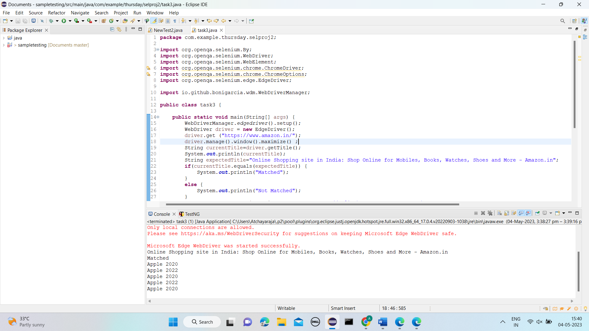

3.

**package** com.example.demo.sampletesting;

**import** org.openqa.selenium.By;

**import** org.openqa.selenium.WebDriver;

**import** org.openqa.selenium.WebElement;

**import** org.openqa.selenium.chrome.ChromeDriver;

**import** org.openqa.selenium.chrome.ChromeOptions;

**import** org.openqa.selenium.edge.EdgeDriver;

**import** io.github.bonigarcia.wdm.WebDriverManager;

**public** **class** task4 {

**public** **static** **void** main(String[] args) {

WebDriverManager.*edgedriver*().setup();

WebDriver driver = **new** EdgeDriver();

driver.get ("https://www.amazon.in/");

driver.manage().window().maximize() ;

String currentTitle=driver.getTitle();

System.***out***.println(currentTitle);

String expectedTitle="Online Shopping site in India: Shop Online for Mobiles, Books, Watches, Shoes and More - Amazon.in";

**if**(currentTitle.equals(expectedTitle)) {

System.***out***.println("Matched");

}

**else** {

System.***out***.println("Not Matched");

}

driver.findElement(By.*xpath*("//*[@id=\"nav-link-accountList\"]")).click();

WebElement txtBoxl=driver.findElement(By.*xpath*("//*[@id=\"ap_email\"]"));

txtBoxl.sendKeys("8667230378");

driver.findElement(By.*xpath*("//*[@id=\"continue\"]")).click();

WebElement txtBox2=driver.findElement(By.*xpath*("//*[@id=\"ap_password\"]"));

txtBox2.sendKeys("rajamalar.11");

driver.findElement(By.*xpath*("//*[@id=\"signInSubmit\"]")).click();

driver.findElement(By.*xpath*("//*[@id=\"nav-link-accountList\"]")).click();

driver.findElement(By.*xpath*("//*[@id=\"a-page\"]/div[2]/div/div[2]/div[1]/a/div/div")).click();

driver.findElement(By.*xpath*("//*[@id=\"a-autoid-2-announce\"]")).click();

driver.findElement(By.*xpath*("//*[@id=\"ordersInPackage-container\"]/div/div/a[1]")).click();

}

}

